EMERGENCY ASTHMA PLAN FOR SCHOOL
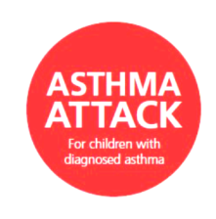
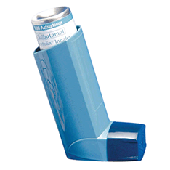
SIGNS OF:
WHEEZING
COUGHING
SHORTNESS OF BREATH
TREATMENT:
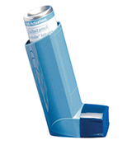
GIVE 1 – 10 puffs of RELIEVER (BLUE) INHALER every 30-60 secs
(USE A SPACER IF IT IS THIS TYPE OF INHALER)

IF NO OR MINIMAL EFFECT, call 999 for an ambulance
1 2

If little or no improvement, and the ambulance has not arrived

Contact 999 again immediately

If the ambulance has not arrived after 10 mins, or symptoms are not improving:
GIVE 1 – 10 puffs of RELIEVER (BLUE) INHALER every 30-60 secs

