

**London schools’ guide**

**for the care of children and young people with asthma**

**February 2021**

**Healthy London Partnership based on Islington schools’ document**

**Review date February 2024**

**Pre-school, primary and secondary school years**

**Contents**

**Introduction** 3

**Record keeping** 4

**Parents’ responsibilities** 5

**School Management and Teachers’ responsibilities** 6

**Schools’ Asthma Lead /Champions’ responsibilities** 7

**All staff responsibilities** 8

**Safe storage** 9

**Safe disposal** 9

**PE/Activities** 9

**School environment** 10

**Students who miss school due to asthma** 11

**Asthma attacks** 11

**Appendix 1 Asthma Friendly School status example parent information** 12

**Appendix 2 Legislation** 13

**Appendix 3 Specimen parent asthma letter** 15

**Appendix 4 Definition of roles** 16

**Appendix 5 Record of inhaler administered to children in primary school** 17

**Appendix 6 Specimen parent letter of salbutamol inhaler use except for pre-agreed sport use** 18

**Appendix 7 School asthma register template** 19

**Appendix 8 Sample school asthma plan** 20

**Appendix 9 Example School-wide asthma plan** 21

**Appendix 10 Specimen parent letter - to inform parents of emergency salbutamol inhaler use** 24

**Appendix 11 Record of emergency inhaler administered to pupils** 25

**Appendix 12 Suggested audit checklist** 26

**Appendix 13 Management of children with asthma in school audit (2020/21)** 28

**Appendix 14 Checklist: Emergency kit** 30

**Appendix 15 Using a spacer device** 31

**Appendix 16 Useful resources: Where to find more information online** 32

**Appendix 17 Useful local contact information** 33

**Appendix 18 Acknowledgements** 34

|  |
| --- |
| **Introduction** ____________________________________________  Asthma is the most common long-term medical condition in children. It is an inflammatory condition that affects the airways. It cannot be cured, but with appropriate management quality of life can be improved.  Having asthma has implications for a child’s schooling and learning. It impacts on care given within schools and early years’ settings. Appropriate asthma care is necessary for the child’s immediate safety, long-term well-being and optimal academic performance. Whilst some older children may be fully independent with their condition younger children, children with learning difficulties or those newly diagnosed are likely to need support and assistance from school staff during the school day, to help them to manage their asthma in the absence of their parents.  The [2010 Children, Schools and Families Act](https://www.legislation.gov.uk/ukpga/2010/26/contents) and the [Children and Families Act 2014](https://www.legislation.gov.uk/ukpga/2014/6/contents/enacted) introduce a legal duty on schools to look after children with medical conditions. This is inclusive of children with asthma and it is therefore essential that all school staff and those who support younger children have an awareness of this medical condition and the needs of pupils with this condition.  The [asthma friendly schools (AFS) programme](https://www.healthylondon.org/resource/london-asthma-toolkit/schools/asthma-friendly-schools/) (**Appendix 1**) sets out clear, effective partnership arrangements between health, education and local authorities for managing children and young people with asthma at primary and secondary schools. For more information about the AFS programme contact the school nurse.  **Purpose and summary of this document**  To enable schools to manage children and young people with asthma effectively in a school setting.  The following is a summary of the recommendations contained within this document and are based on guidelines derived from clinical practice at Whittington Health, London Borough of Islington and from contributions from key stakeholders from across London.   * **Every child with asthma should have an individual health care plan (IHCP)** * **Each school has an up to date medical /asthma conditions policy** * **Children and young people should have appropriate supervision depending on their individual needs** * **Children and young people should have immediate access to their inhalers ideally in the classroom. It is the school’s responsibility to make sure staff know where the inhalers are kept.** * **In an asthma attack the inhaler should always be taken to the child** * **Schools should ensure they have at least one emergency asthma inhaler kit available** * **Early years settings and primary schools: Children and young people may require support to manage their asthma in school in line with the Children and Families Act 2014. Schools should use their allocated funds for this (delegated school budget)** * **Secondary school: The student will be largely independent but may require intermittent support** * **The school will maintain a register of children and young people with asthma** * **Staff will have access to appropriate training and annual updates**   This policy reflects the requirements of key legislation (**Appendix 2**) and in particular two key documents:  1**.** [**Supporting pupils at school with medical conditions (2014**](https://assets.publishing.service.gov.uk/government/uploads/system/uploads/attachment_data/file/803956/supporting-pupils-at-school-with-medical-conditions.pdf))[1] and  2**.** [**Guidance on the use of emergency salbutamol inhalers in schools**](https://assets.publishing.service.gov.uk/government/uploads/system/uploads/attachment_data/file/416468/emergency_inhalers_in_schools.pdf) (2015)[2]  This policy sets out how a school can support students with asthma. The school works closely with students, parents and health colleagues to ensure it has robust procedures in place for the administration, management and storage of asthma inhalers at school. Parents/guardians are kept informed if their child has had medication during the school day.  Parents are required to ensure the school is aware of their child’s needs (**Appendix 3**). Parents should assist in the completion of their child’s school asthma plan and also provide the school with one named inhaler and spacer in the original packaging detailing the prescription. For primary school children the inhaler and spacer should be kept in the classroom whilst secondary school students should carry the inhaler (and associated spacer) themselves.  The school management and governors should ensure that an Asthma Champion (see **Appendix 4** for definition of roles) will check the expiry dates of medications every half term and advise parents if new medication is required. It is the responsibility of parents/guardians to ensure all medication is in date as advised by the school Asthma Champion and that the school are kept informed of any changes to children’s medication/care needs throughout their time at school.  School staff are not obliged to administer medication however some will be happy to do so. School staff are insured to administer medication under the school’s or local education authority’s public liability insurance policy.  Students with asthma are fully integrated into school life and can participate fully in all activities including physical education (PE). Students always require open and immediate access to their reliever medication (inhaler) for all school activities; schools should have clear procedures in place that facilitate this. **Record keeping** ____________________________________________  It is the responsibility of parents/guardians to inform school on admission of their child’s medical condition and needs (**Appendix 3**). It is also important that the school are informed by parents of any changes. The school will keep an accurate record of each occasion a student is given or supervised taking their inhaler. If recording takes place in more than one location i.e. classroom and office – the record is amalgamated to clearly reflect frequency of use. Ideally there should be one record. (Record of administration template **Appendix 5**) Details of the supervising staff member, student, dose, date and time are recorded. Parents will be informed if a student uses their inhaler at any time unless taken pre-sport as agreed. (**Appendix 6**).  If a pupil refuses to use their inhaler, this is also recorded and parents are informed as soon as possible.  Schools keep an asthma register **(Appendix 7)** so that they can identify and safeguard students with asthma; this is held in the classroom and school office.  Students with asthma will have a school asthma plan **(example Appendix 8)** This is written jointly between health, education and parent/student. An alternative to an individual school asthma plan is for a school-wide emergency asthma plan (**example** **Appendix 9**). Any child or young person with complex asthma should have an individual asthma plan.  In the event a student’s inhaler and spare inhaler are unavailable/ not working the school will use the schools’ emergency inhaler (if the parent/guardian has consented) and inform the parent as soon as possible **(Appendix 10).** Consent to use emergency inhalers should be recorded on the asthma register and the pupil’s Individual Health Care Plan (IHCP). **Parents’ responsibilities** ____________________________________________   * Informing the school if their child has asthma. * Ensure their child has an up-to-date written self-management plan from their doctor or specialist healthcare professional and that they share this with the school. If the school’s policy is a school-wide emergency asthma plan an individual plan may not be required (Appendix 9). Any child or young person with complex asthma should have an individual asthma plan. * Inform the school about the medicines their child requires during school hours. * Inform the school of any medicines the child requires while taking part in visits, outings, field trips and other out-of-school activities such as school sports events. * Inform the school of any changes to their child’s condition. * Ensure their medicines and medical devices are labelled with their full name and date of birth, in the original pharmacy packaging. * Ensure that their child’s medicines are within their expiry dates once advised by the school Asthma Champion. * Ensure that their secondary school student takes their inhaler to school and is confident about telling others if they are feeling unwell and needs to use their inhaler. * If their child is off school, they catch up on any school work they have missed. * Ensure their child has regular reviews (at least annually and after each exacerbation) with their doctor or specialist healthcare professional. * Ensure in date medicines come into school on the first day of the new academic year. Spacers need to be replaced annually if used regularly. |
| **School Management and Teachers’ responsibilities**  ____________________________________________   * School management team ensure that the school’s asthma policy is read and understood by all members of staff including teachers, teaching assistants, support staff and catering staff * Be aware of the potential triggers, signs and symptoms of asthma and know what to do in an emergency * Know which students have asthma and be familiar with the content of their individual health plan * Allow all students to have immediate access to their emergency medicines * Inform parents if a child uses their inhaler after an exacerbation or in the playground * Encourage parents to seek a clinical review if a child regularly uses their inhaler at school * Maintain effective communication with parents including informing them if their child has been unwell at school * Ensure students who carry their medicines with them, have them when they go on a school trip or out of the classroom * Be aware that asthma can affect a student’s learning and provide extra help when needed * Be aware of children with asthma who may need extra social support * Liaise with parents, the student’s healthcare professionals, special educational needs co-coordinator and welfare officers if a child is falling behind with their work because of their condition * Use opportunities such as Personal Social Health & Economic (PSHE) education to raise pupil awareness about asthma (Healthy London Partnership’s website has example [lesson plans and videos](https://www.healthylondon.org/resource/london-asthma-toolkit/schools/presentations-for-teaching/)) * Understand asthma and the impact it can have on students (students should not be forced to take part in an activity if they feel unwell). If school identify a pattern or are concerned about an individual student, they will inform their parent/guardian and seek medical advice. * Ensure students with asthma are not excluded from activities in which they wish to take part. * Ensure secondary school students have the appropriate medication with them during activity or exercise and are allowed to use them when needed * School management review the asthma policy annually and conduct an annual review of the safe management of asthma in the school |
| **Schools’ Asthma Lead /Champions’ responsibilities**  ____________________________________________ |
| The school asthma lead and Asthma Champions are delegated responsibility by the head teacher and school governors to ensure:   * Schools have an adequate supply of emergency kits and know how to obtain these from their local pharmacy * Procedures are followed * Register is up-to date and accessible to all staff * All children on the register have consent status recorded, an inhaler, a spacer and a care plan. * That medication use in school is monitored. For any salbutamol inhaler use during the school day apart from pre-agreed sport use, parents should be informed (**Appendix 6**). If a pattern of regular use is emerging at school for example, if a child was using their rescue inhaler three times a week - the school nurse (or asthma CNS if family already has links) should be informed. * Expiry dates are checked at least every half term and impending expiry dates are communicated to parent/guardian. * Replacement inhalers are obtained before the expiry date * Empty/out of date inhalers are disposed of appropriately (see section 8) * Their own training is up-to-date * The school’s policy in practice is audited annually. The Asthma Champions/Leads enable the school nurse or CNS to undertake the annual audit **(Appendices 12 and 13 audit checklists)** * Ensure inhalers and spacers are washed and checked regularly according to instructions; care should be taken not to muddle the components as this could pose a risk to the allergic child. If the inhaler and spacer have not been used and have been stored correctly in their own sealed packaging there is no need for them to be washed. * Emergency kits are checked regularly and contents replenished immediately after use * Asthma Leads/ Champions are trained and confident to support in an emergency situation  **All staff responsibilities** ____________________________________________   * Attend asthma training yearly * Know what the procedures are and which students have asthma, be familiar with their care plans * Communicate parental concerns and updates to the Asthma Lead/Champions * Inform the Asthma Lead/Champion if a school emergency inhaler has been used * Record inhaler usage as per their school system for recording. If recording takes place in more than one location i.e. classroom and office – the record is amalgamated to clearly reflect frequency of use. Ideally there should be one record * Record the usage in the main asthma register located in the school office if the schools’ emergency inhaler has been used * Ensure all students with asthma have easy access to their reliever inhaler and spacer * Encourage all students to carry and administer their own inhaler when their parents and health care provider determine they are able to start taking responsibility for their condition. This is likely to be only secondary school students * Ensure students who do not carry and administer their own emergency medication know where their inhalers are stored. This should preferably be in the classroom and not in the main school office. This is likely to be for primary school students * Ensure all staff attending off site visits are aware of any students on the visit with asthma and have brought their medication. They should be trained about what to do in an emergency * Ensure that, if a student misuses medication, either their own or another student, their parents are informed as soon as possible, and they are subject to the school’s usual disciplinary procedures  **Safe storage**  **_________________________________________________________________________**  **General**   * All inhalers are supplied and stored, wherever possible, in their original containers. All medication needs to be labelled with the student’s name and date of birth, the name of the medicine, expiry date and the prescriber’s instructions for administration, including dose and frequency. * Medicines are stored in accordance with instructions at room temperature. * All inhalers and spacers are sent home with students at the end of the school year. Medications are not stored in school over the summer holidays   **Emergency medicine**   * Emergency medications are readily available to students who require them at all times during the school day whether they are on or off site. * Secondary school students who are self-managing are reminded to carry their inhalers and spacers with them at all times.  **Safe disposal**  ____________________________________________  Parents are responsible for collecting out of date medication from school.  A named member of staff is responsible for checking the dates of medication and arranging for the disposal of those that have expired.  Manufacturers’ guidelines usually recommend that spent inhalers are returned to the pharmacy to be recycled. Schools should be aware that to do this legally, they should register as a lower-tier waste carrier, as a spent inhaler counts as waste for disposal. Registration only takes a few minutes online, is free, and does not usually need to be renewed in future years. <https://www.gov.uk/waste-carrier-or-broker-registration> |

# **PE/Activities**

**_____________________________________________**

The school management and governors need to ensure that the whole school environment, which includes physical, social, sporting and educational activities, is inclusive and favourable to students with asthma.

Physical Education (PE) teachers will be sensitive to students who are struggling with PE and be aware that this may be due to uncontrolled asthma. Parents should be made aware so medical help may be sought.

This includes out of school visits, which schools ensure are accessible to all students.

Children and young people with asthma will have equal access to extended school activities, school productions, after school clubs and residential visits.

Staff will have training and be aware of the potential social problems that students with asthma may experience. This enables schools to prevent and deal with problems in accordance with the school’s anti bullying and behaviour policies**.**

Staff use opportunities such as Personal, Social Health & Economic (PSHE) education lessons to raise awareness of asthma amongst students and to help create a positive social environment and eliminate stigma. School staff understand that pupils with asthma should not be forced to take part in an activity if they feel unwell.

Staff are trained to recognise potential triggers for pupil’s asthma when exercising and are aware of ways to minimise exposure to these triggers.

PE teachers should make sure students have their inhalers with them during PE and take them when needed as stated in their plan; before, during or after PE. For primary school children this will be the school held inhaler and for secondary school students, their own.

Risk assessments will be carried outfor any out of school visits. Factors considered include how routine and emergency medicines will be stored and administered and where help could be obtained in an emergency. Schools should recognise there may be additional medication, equipment or factors to consider when planning residential visits. These may be in addition to any medicines, facilities and healthcare plans that are normally available in school.

In an emergency situation all members of school staff are required under common law duty of care, to act like any reasonable parent. This may include administering medication. The school management should ensure that there are asthma emergency procedure posters on display in prominent places e.g., the staff rooms, the school office and reception and gymnasiums.

# **School environment**

_____________________________________________

The school environment, as far as possible, is kept free of the most common allergens that may trigger an asthma attack. They should not keep warm blooded pets (for example dogs, rabbits or guinea pigs) inside the school premises. Smoking is explicitly prohibited on the school site. There are other [asthma triggers](https://www.asthma.org.uk/advice/triggers/indoor-environment/#toptipsindoor), for example house dust mites, viruses, damp, mould and [air pollution](https://www.cleanairhub.org.uk/). [Idling in cars](https://www.blf.org.uk/your-stories/why-you-should-dropoffswitchoff-at-the-school-gates), which means keeping the engine running while stationary when waiting to drop off or pick-up children from school, increases the amount of toxic pollutants in the air which can trigger asthma symptoms. Exposure to these triggers should be limited wherever possible.

Chemicals in science, cookery and art have the potential to trigger an asthma response and teachers and support staff should be aware of any students who may be at risk from these activities

Students who are known to have specific triggers will not be excluded from any activities and alternative options will be sought if required. Cleaning and grass cutting should, where possible, be carried out at the end of the school day.

# **Students who miss school due to asthma**

_____________________________________________

The school management should be monitoring students’ absence. For example, if a student is having a lot of time off school due to their asthma, or the student is identified as being constantly tired in school, staff will make contact with the parent to work out how they can be supported. The school may need to speak with the school nurse or other health professional to ensure the student’s asthma control is optimal.

All schools are now trained in how to manage asthma and there is no reason for a child to miss out on education due to asthma. For more information on training, contact your local school nursing team. Poor asthma control should not be accepted as a reason for missing school or being late, and as such local policy around missing school and referral to educational welfare teams should not be delayed for this reason, however, it must also trigger referral to the school nursing team.

# **Asthma attacks**

_____________________________________________

Staff should be trained to recognise an asthma attack and know how to respond. For more information on training please contact your school nursing team. It is good practice to clearly display the procedure to be followed on posters in the staff room and office as a reminder. Please see **Appendix 9** for a sample poster and **Appendix 14** for example emergency kit.

If a child has an asthma attack in school a member of staff will remain with them throughout and administer their inhaler in accordance with the emergency procedure. **No student should ever be sent to get their inhaler in this situation; the inhaler must be brought to the student.** Emergency services and parents will be informed. Post attack the school nurse will be informed. S/he can then ensure that others in primary and community care are aware.

A member of staff will accompany the student to hospital until their parent/care giver arrives***.***

# **Appendix 1 Asthma Friendly School status example parent information**

The [asthma friendly schools (AFS) programme](https://www.healthylondon.org/resource/london-asthma-toolkit/schools/asthma-friendly-schools/) sets out clear, effective partnership arrangements between health, education and local authorities for managing children and young people with asthma at primary and secondary schools.

We are an asthma friendly school and have gained asthma friendly status for our care of students with asthma. This means we advocate inclusion, are clear on our procedures and have designated asthma leads to ensure these are adhered to. We commit to the audit of our procedures yearly. This policy will be reviewed annually by ________________________

We welcome parents and students’ views on how we can continue to improve and build upon our standards.

The school recognises that asthma is a prevalent, serious but manageable condition and we welcome all students with asthma. This policy was drawn up in consultation with parents, students, School Nurses, Local Authority, School Governors and health colleagues.

We ensure all staff are aware of their duty of care to students. We have a “whole school” approach to regular training so staff are confident in carrying out their duty of care. We have two Asthma Leads, they are called:

1.

2.

Asthma Leads ensure procedures are followed and a “whole school” approach to training is delivered.

# **Appendix 2 Legislation**

**The Children and Families Act 2014**

Section 100 of the Children and Families Act 2014 introduced a legal duty on schools to look after children with medical conditions. This is inclusive of children with asthma. Schools must make arrangements to support pupils at school with medical conditions and have regard to the statutory guidance: See [**Supporting pupils at school with medical conditions**](https://www.gov.uk/government/uploads/system/uploads/attachment_data/file/306952/Statutory_guidance_on_supporting_pupils_at_school_with_medical_conditions.pdf)

**The Education Act 2002**

Sections 21 and 175 detail how governing bodies of maintained schools must promote the wellbeing of pupils and ensure the safeguarding of children at the school.

**Section 3 of the Children Act 1989**

This places a duty on a person with the care of a child to do all that is reasonable in the circumstances for the purposes of safeguarding and promoting the child’s wellbeing. With relation to a child with asthma, this will mean knowing what to do in the event of an emergency and doing it.

**Legal duties on local authorities**

Local authorities have legal responsibilities to help make sure schools can meet the duties relating to children with asthma. These duties refer to all children in the local authority and they do not depend on the kind of school the child attends.

**Section 10 of the Children Act 2004**

This is a particularly important piece of [legislation](https://www.legislation.gov.uk/ukpga/2004/31/contents) if schools are struggling to get the support and training they need to allow them to look after a child with asthma properly.

Section 10 essentially means the local authority must make arrangements to promote cooperation between the authority and relevant partners. Relevant partners include the governing body of a maintained school, the proprietor of an academy, clinical commissioning groups and the NHS Commissioning Board. They must make arrangements with a view to improving the wellbeing of children, including their physical and mental health, protection from harm and neglect, and education.

**Section 17 of the Children Act**

This gives local authorities a general duty to safeguard and promote the welfare of children in need in their area. If a school is looking after a child with asthma so poorly that the child is put in danger, the local authority must step in.

**Legal duties on the NHS**

**Section 3 of the NHS Act 2006**

This gives Integrated Care Systems (ICSs) a duty to arrange for the provision of health services to the extent they considers it necessary to meet the reasonable needs of the people for whom it is responsible. This means ICSs should provide the healthcare the people in its area need, if these needs are reasonable.

This section also provides for ICSs to arrange such services as it considers appropriate to secure improvements in physical and mental health, and in the prevention, diagnosis and treatment of illness, in people for whom it is responsible

In relation to children with asthma, this means that an ICS should, within reason, make sure support and health care is in place to improve their health or at least keep them healthy. Poor management of asthma at school will obviously affect the health of a child. If a school is unable to get the support it needs to help manage a child’s asthma successfully then both the local authority and the local ICS have a responsibility to the child’s health and welfare.

**Equality Act (2010)**

This states that types of discrimination are illegal, defining discrimination as when a person with a disability is treated less favourably, because of his or her disability, than a person who does not have a disability. The Equality Act 2010 defines a disability as a 'physical or mental impairment' that has 'a substantial and long-term adverse effect' on an individual’s ability to carry out 'normal day-to-day activities'. A substantial adverse effect is a negative effect that is more than trivial, and the effect is long-term if it has lasted or is expected to last for more than twelve months. Whilst only a court or tribunal can decide whether a person with asthma is covered by the definition, in many cases asthma is covered by the definition of the Act.

Education and early years providers have a duty to make reasonable adjustment for people with disabilities and failure to make reasonable adjustments is a form of discrimination. The Act covers all schools and providers of early years settings that are covered by the early years framework in England, including maintained (non-fee paying) and fee-paying schools.

# **Appendix 3 Specimen parent asthma letter**

Dear Parent/Guardian

We are currently reviewing our asthma policy. Please would you update the information regarding your child so we can ensure our school records are accurate.

Our updated asthma policy means we will have an **emergency** salbutamol reliever inhaler on site. This is a precautionary measure. You still need to provide your child with their own inhaler and spacer as prescribed. If you **do not** wish for us to use the schools’ inhaler in an emergency, please fill in the details below and return to school as soon as possible.

Please note that everyone with asthma should use a spacer with their inhaler in order to deliver maximum benefit to the lungs (unless your child has a breath actuated inhaler). If your child does not have a spacer or has not had an asthma review in the past 12 months, please book an appointment with your GP as soon as possible. For more information on reasons for and how to use a spacer see Asthma UK [www.asthma.org.uk](http://www.asthma.org.uk)

Please complete the information below and return to school

Yours sincerely

* 1. I confirm that my child has been diagnosed with asthma
  2. I confirm my child has been prescribed an inhaler
  3. My child has a working, in-date inhaler, and spacer clearly labelled with their name, which they will have with them at school every day.
  4. Please tick if you **DO NOT** wish the school to use the schools’ inhaler in an emergency

Signed:

Date:

Print name:

Child’s name:

Class:

# 

# **Appendix 4 Definition of roles**

**Asthma Champion** – A school Asthma Champion is a non-clinical member of staff who takes an active role supporting the school with the practical implementation of their asthma policy. They should link with others outside the school for support e.g. asthma clinical nurse specialist (CNS), a local GP and local community asthma team. An Asthma Champion is usually a member of staff at the school - the welfare officer is ideally placed or a staff member with an interest in children’s asthma and they may be part of a local asthma network.

**Asthma CNS** (clinical nurse specialist) - [Asthma CNSs](https://www.asthma.org.uk/advice/nhs-care/healthcare-team/#Paediatricasthmanurses) are healthcare professionals trained in paediatric respiratory medicine who specialise in helping children who have breathing conditions or problems with their lungs. These nurses specialise in supporting children with a range of conditions, including asthma. Their skills, knowledge and expertise are particularly geared towards helping children and their families from childhood through to young adulthood [when they move into adult services](https://www.asthma.org.uk/advice/nhs-care/get-the-best/transition/).

**Asthma Lead** – A school Asthma Lead is a member of school staff who takes a lead role within the school to ensure the asthma policy is implemented. They should be part of the Senior Leadership Team within the school and support the Asthma Champion's role within the school.

**School nurse** – A [school nurse](https://www.asthma.org.uk/advice/nhs-care/healthcare-team/#schoolnurse) is a registered nurse who has experience and training in public and child health. A school won’t normally have a full-time nurse but may share a nurse with a number of other local schools. School nurses provide health-promotion services in schools and weekly drop-in sessions or one-to-one appointments for students or parents to discuss any concerns they may have.

**School support staff** - There are many types of support staff that help children learn: teaching and classroom assistants; learning support assistants; learning mentors; librarians; science technicians; ICT technicians; food technicians; and design and technology technicians. They help the school run smoothly and also include school business managers; cover supervisors; examination officers; school attendance officers; admin assistants; finance officers; and secretaries.

# **Appendix 5 Record of inhaler administered to children in primary school**

|  |  |
| --- | --- |
| Name of school/setting |  |

|  |  |  |  |  |  |  |  |
| --- | --- | --- | --- | --- | --- | --- | --- |
| Date | Child’s name | Time | Name of medicine | Dose given | Spacer cleaned | Signature of staff | Print name |
|  |  |  |  |  |  |  |  |
|  |  |  |  |  |  |  |  |
|  |  |  |  |  |  |  |  |
|  |  |  |  |  |  |  |  |
|  |  |  |  |  |  |  |  |
|  |  |  |  |  |  |  |  |
|  |  |  |  |  |  |  |  |
|  |  |  |  |  |  |  |  |
|  |  |  |  |  |  |  |  |
|  |  |  |  |  |  |  |  |
|  |  |  |  |  |  |  |  |
|  |  |  |  |  |  |  |  |
|  |  |  |  |  |  |  |  |

Parents should be notified on every occasion if a student is using their inhaler except for agreed pre-sport use.

**Please be aware of those students who carry their own inhaler and self-medicate**. A record of such use should be kept. Under the Data Protection Act 1998 (DPA), schools are responsible for ensuring that the collation, retention, storage and security of all personal information they produce and hold meets the provisions of the DPA[3].

# **Appendix 6 Specimen parent letter of salbutamol inhaler use except for pre-agreed sport use**

SCHOOL NAME HERE

Child’s name: ...................................................

Class: ..................................................

Date: ...................................................

Dear ...................................................

This letter is to formally notify you that………………………………….has had problems with their breathing today and required their reliever (rescue) inhaler. ……. number of puffs were given at ……………….. <insert time and date>.

If your child has been using their rescue inhaler at home as well, we encourage you to contact your doctor’s surgery for a clinical review.

Yours sincerely,

|  |  |  |  |  |
| --- | --- | --- | --- | --- |
| **Appendix 7 School asthma register template**  The HLP website includes an [excel spreadsheet](https://www.healthylondon.org/sites/default/files/Example%20asthma%20register%20for%20schools.xlsx) which red flags when medication is out of date | | | |  |
| **Name** | **Class** | **DOB** | **Consent to use emergency inhaler** | |
|  |  |  |  | |
|  |  |  |  | |
|  |  |  |  | |
|  |  |  |  | |
|  |  |  |  | |
|  |  |  |  | |
|  |  |  |  | |
|  |  |  |  | |
|  |  |  |  | |
|  |  |  |  | |
|  |  |  |  | |
|  |  |  |  | |
|  |  |  |  | |
|  |  |  |  | |
|  |  |  |  | |
|  |  |  |  | |
|  |  |  |  | |
|  |  |  |  | |

# **Appendix 8 Sample school asthma plan**

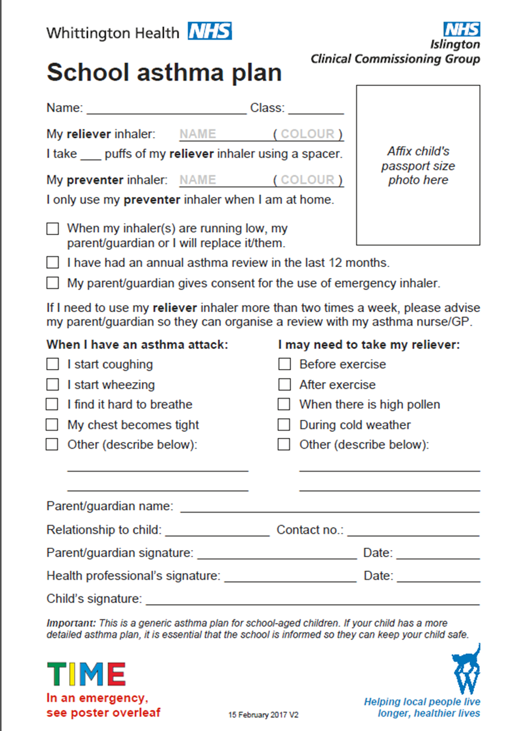

# **Appendix 9 Example School-wide asthma plan**

**Complex asthmatics should have their own asthma plan**

[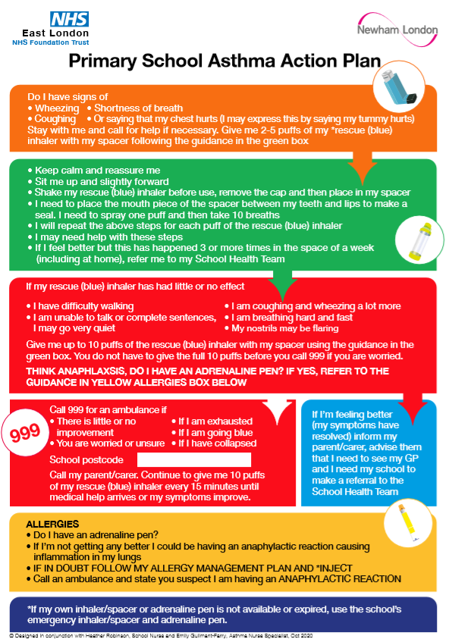](C://Users/SubhaniA/AppData/Local/Microsoft/Windows/INetCache/Content.Outlook/EKQXJABW/LBN%20Primary%20Asthma%20Action%20Plan%20A4.pdf)

[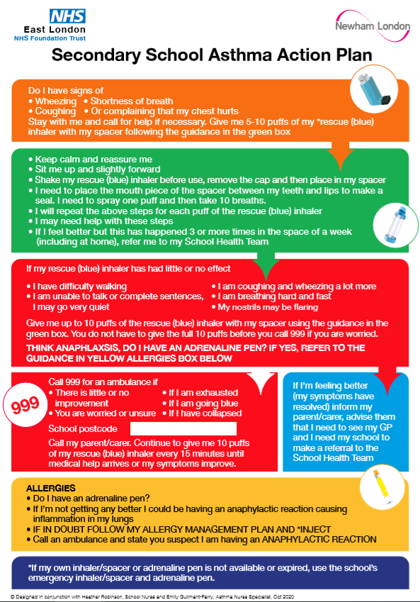](C://Users/SubhaniA/AppData/Local/Microsoft/Windows/INetCache/Content.Outlook/EKQXJABW/LBN%20Secondary%20Asthma%20Action%20Plan%20A4.pdf)

[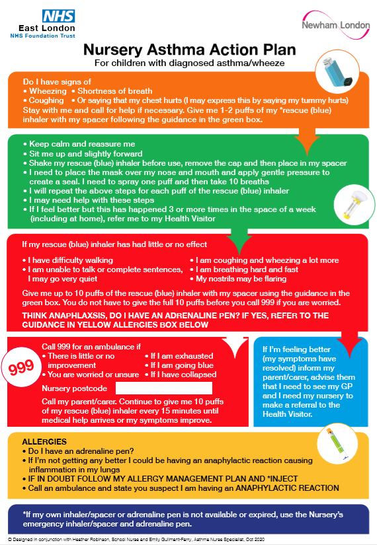](C://Users/SubhaniA/AppData/Local/Microsoft/Windows/INetCache/Content.Outlook/EKQXJABW/LBN%20Nursery%20Asthma%20Action%20Plan%20A4.pdf)

# **Appendix 10 Specimen parent letter - to inform parents of emergency salbutamol inhaler use**

SCHOOL NAME HERE

Child’s name: ………………………………………………………………………………………………………

Class: ………………………………………………………………………………………………………………………………………………………………………………………………………………

Date: ……………………………………………………………………………………………….

Dear………………………………………………………………………………………………..

This letter is to formally notify you that …………………………………. has had problems with their breathing today.

This happened when …………………………………………………………………………………………….

They did not have their own asthma inhaler with them, so a member of staff helped them to use the school emergency asthma inhaler containing salbutamol. They were given ………………..… puffs.

Although they soon felt better, we would strongly advise that your child is seen by their own doctor or asthma nurse as soon as possible.

***Please can you ensure your child brings in a working in-date inhaler and spacer for their use in school: both should be clearly labelled with your child’s name and date of birth.***

Yours sincerely,

# **Appendix 11 Record of emergency inhaler administered to pupils**

Name of school/setting

|  |  |  |  |  |  |  |  |  |
| --- | --- | --- | --- | --- | --- | --- | --- | --- |
| **Date** | **Child’s name** | **Time** | **Name of medicine** | **Dose given** | **Spacer given to child as single use only** | **New spacer obtained** | **Signature of staff** | **Print name** |
|  |  |  |  |  |  |  |  |  |
|  |  |  |  |  |  |  |  |  |
|  |  |  |  |  |  |  |  |  |
|  |  |  |  |  |  |  |  |  |
|  |  |  |  |  |  |  |  |  |
|  |  |  |  |  |  |  |  |  |
|  |  |  |  |  |  |  |  |  |
|  |  |  |  |  |  |  |  |  |
|  |  |  |  |  |  |  |  |  |
|  |  |  |  |  |  |  |  |  |
|  |  |  |  |  |  |  |  |  |
|  |  |  |  |  |  |  |  |  |
|  |  |  |  |  |  |  |  |  |
|  |  |  |  |  |  |  |  |  |
|  |  |  |  |  |  |  |  |  |

# **Appendix 12 Suggested audit checklist**

|  |  |
| --- | --- |
| **Standard 1**  **Policy**  School’s policy should be available to view, all staff should be aware of where it is kept. | **Details**  Amended the Template policy to reflect internal procedures. All staff and parents are aware of the policy. (please note evidence source)  Date for review  Named contact that has responsibility for review of policy**.** |
| **Standard 2**  **Asthma Register** | Register should clearly state name and DOB of student. Consent to administer emergency medication should also be recorded.  If prevalence was low (less than 10%) at initial audit a sweep of whole school should have been undertaken and register updated with newly identified students.  Consent for use of emergency inhaler recorded on register.  Must be displayed in school office and staffroom/common room with Emergency poster. |
| **Standard 3**  **Emergency Kits/Procedures** | Emergency kits (minimum of 2 in any school) conveniently located at key points throughout the school. Staff aware of where these are and have easy access to them.  Emergency kit for off-site activities/evacuation of building.  Contains checklist and clear procedures on monitoring use and contents.  Parents are informed promptly if emergency kit is required and advised to bring child for review.  Asthma Champion/ Leads are easily identified by staff members |
| **Standard 4**  **Individual Health Care Plan (IHCP)**  **Recording use of students’ medications**  **Students who self-manage**  **Storage of inhalers/spacers** | Students have a care plan and know where it is kept – usually in the school office. For more information about how to develop an IHCP and what it should include see [annex A DfE guidance](https://assets.publishing.service.gov.uk/government/uploads/system/uploads/attachment_data/file/803956/supporting-pupils-at-school-with-medical-conditions.pdf). An alternative to an IHCP is for a school-wide emergency asthma plan (example **Appendix 9**). Any child or young person with complex asthma should have an individual asthma plan.  Records kept of medication usage and parents informed promptly of any incidents/usage outside of the IHCP.  Check that if recording takes place in more than one location i.e. classroom and office – the record is amalgamated to clearly reflect frequency of use. Ideally there should be one record.  Students should be encouraged to self-manage their condition where appropriate (secondary school students).  Asthma medication and spacer is clearly labelled and stored in a cool location  Expiry dates are checked regularly by staff and  replaced when required.  Inhaler is administered via a spacer  Spacers are single person use |
| **Standard 5**  **Whole school training** | Asthma training should be taken up by the whole school – a minimum of 85% is required to achieve AFS status. |

# **Appendix 13** [**Management of children with asthma in school audit (2020/21)**](https://www.nwlondonccgs.nhs.uk/publications/publications/navigate/4104/4409#ccm-block-document-library-4104)

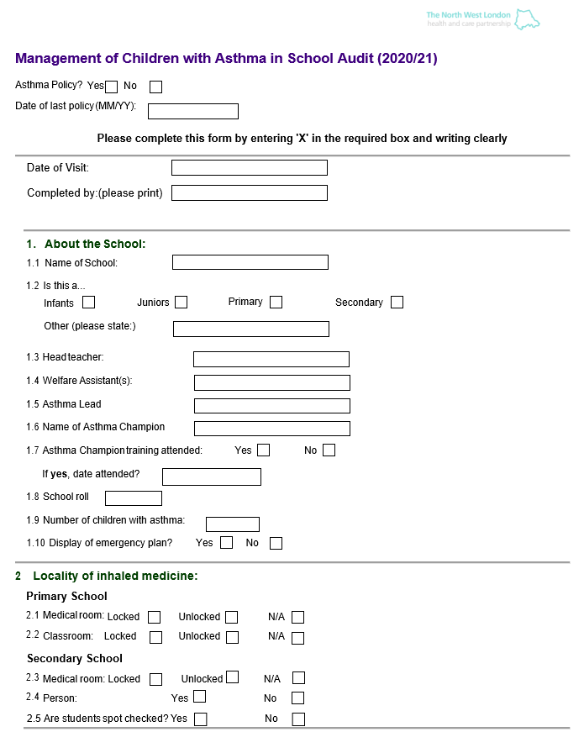

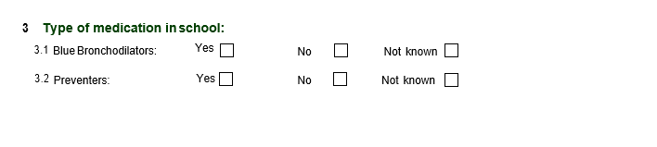

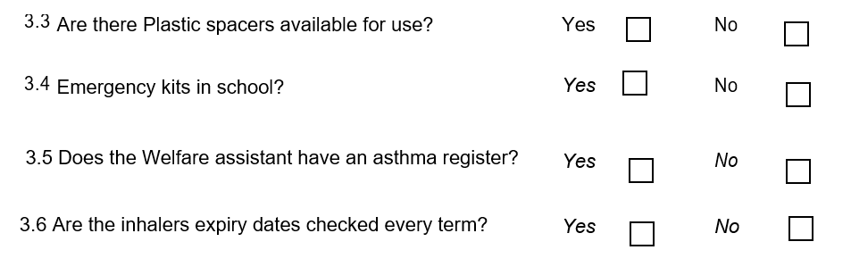

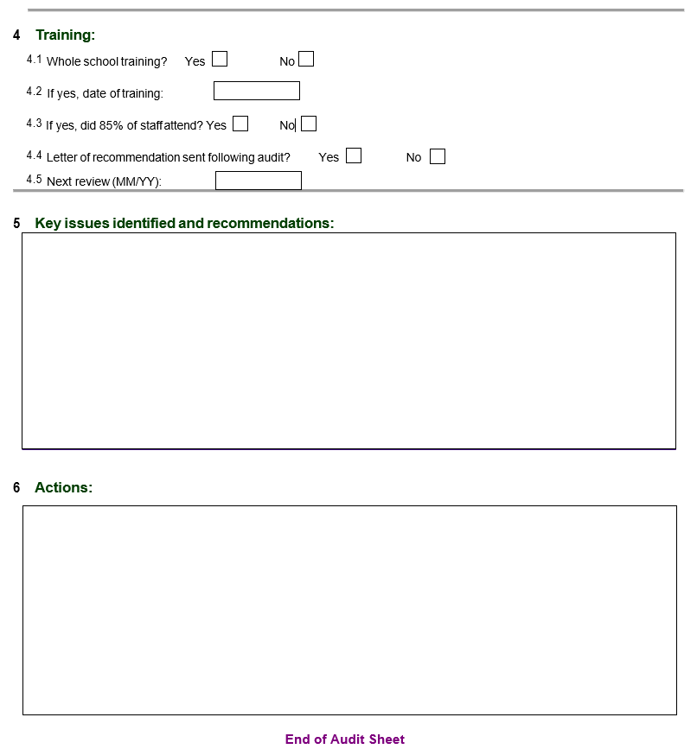

# **Appendix 14 Checklist: Emergency kit**

|  |  |  |  |
| --- | --- | --- | --- |
| **An emergency asthma inhaler kit should include:** | **Yes** | **No** | **Checked by/date** |
| Two salbutamol metered dose inhalers |  |  |  |
| At least two single-use plastic or disposable spacers compatible with the inhaler;  Once used the plastic spacer should be sent home with the child who has used it. It cannot be used for another child |  |  |  |
| Instructions on using the inhaler and spacer/plastic chamber |  |  |  |
| Advice that the salbutamol inhaler and spacer are single patient use only because of the risk of Covid. Instructions on storing the unused inhaler and unused spacer. Instructions for disposing of the used inhaler. |  |  |  |
| Manufacturer’s information |  |  |  |
| A checklist of inhalers, identified by their batch number and expiry date, with half termly monthly checks recorded |  |  |  |
| A note of the arrangements for replacing the inhaler and spacers |  |  |  |
| A list of children permitted to use the emergency inhaler as detailed in their individual healthcare plans (asthma register with consent recorded) |  |  |  |
| A record of administration (i.e. when the inhaler has been used). |  |  |  |
| Pen |  |  |  |
| Asthma Champions’ details  1.  2. |  |  |  |

# **Appendix 15 Using a spacer device**

Information on spacer use in children and young people can be accessed through [Healthy London Partnership’s asthma toolkit](https://www.healthylondon.org/resource/london-asthma-toolkit/pharmacy/inhalers/), Asthma UK’s videos on [inhalers](https://www.asthma.org.uk/advice/child/medicines/help/) and [spacers](https://www.asthma.org.uk/advice/inhalers-medicines-treatments/inhalers-and-spacers/spacers/) and from [Rightbreathe](https://www.rightbreathe.com/).

# **Appendix 16 Useful resources: Where to find more information online**

[**Gov.uk**](http://Www.gov.uk)**, Emergency asthma inhalers in schools PDF:** [**https://bit.ly/3kiw3da**](https://bit.ly/3kiw3da)

**Gov.uk, Supporting pupils at school with medical conditions and how to complete an IHCP:** [**https://bit.ly/3pQ0yZa**](https://bit.ly/3pQ0yZa)

**Asthma UK schools’ advice:** [**https://bit.ly/2MkeCwj**](https://bit.ly/2MkeCwj)

**Asthma action plan and resources:** [**https://www.asthma.org.uk/advice/resources/**](https://www.asthma.org.uk/advice/resources/)

**Medical conditions at school- Schools Health Alliance**

[**http://medicalconditionsatschool.org.uk/**](http://medicalconditionsatschool.org.uk/)

**Breathe better London**

[**https://www.breathelondon.org/about/**](https://www.breathelondon.org/about/)

**British Lung Foundation**

[**https://www.blf.org.uk/search/site/asthma**](https://www.blf.org.uk/search/site/asthma)

**Monkey Well Being resources and story books**

[**https://www.monkeywellbeing.com/**](https://www.monkeywellbeing.com/)

**Education for health, Educational resources for staff:** [**https://bit.ly/3dMaQHp**](https://bit.ly/3dMaQHp)

**Useful videos**

[**What is Asthma? - Pathophysiology of Asthma**](https://www.youtube.com/watch?v=2ur1XreTiNg&app=desktop): [**https://bit.ly/3klIJjO**](https://bit.ly/3klIJjO)

[**Dr Ranj and Peppa Pig, the unsung hero of paediatric medicine**](https://www.youtube.com/watch?v=kAjMWiuAQZo)**:**

[**https://bit.ly/2ZZzY5D**](https://bit.ly/2ZZzY5D)

[**Operation Ouch and asthma**](https://www.youtube.com/watch?v=zvzAaIYL43I)**:** [**https://bit.ly/2ZN0M8Y**](https://bit.ly/2ZN0M8Y)

[**Importance of using a spacer**](https://www.youtube.com/watch?feature=player_detailpage&v=M_mfMLuRwJQ)**:** [**https://bit.ly/2ZKpPtp**](https://bit.ly/2ZKpPtp)

[**Asthma4children**](https://www.youtube.com/user/Asthma4children/videos)**:** [**https://bit.ly/37JBTPR**](https://bit.ly/37JBTPR)

[**Steroids for asthma and their side effects - Asthma UK**](https://www.youtube.com/watch?v=7r5LPxf2GCU)**:** [**https://bit.ly/37Kh86x**](https://bit.ly/37Kh86x)

[**Parents talk to Asthma UK**](https://www.youtube.com/watch?v=bBE_OVW09Vw)**:** [**https://bit.ly/3bEg9Wy**](https://bit.ly/3bEg9Wy)

# **Appendix 17 Useful local contact information**

**Insert local details below**

**School nurse contact details:**

**Asthma clinical nurse specialist:**

**Children’s community nurses team:**

**Health and wellbeing team:**

**Smoking cessation team:**

# **Appendix 18 Acknowledgements**

Dr Rahul Chodhari, Consultant Paediatrician with an interest in Respiratory medicine and Allergy, Royal Free London Foundation NHS Trust

Azmain Chowdhury, medical student, University College London

Jonny Coppell, medical student, University College London

Anne Corbett, Head of Richard Cloudesley Outreach Service

Colette Datt, Consultant Nurse, Whittington Hospital

David Finch, GP, Asthma Lead, Healthy London Partnership and Medical Director NWL

Dr Richard Iles, National Paediatric Asthma Collaborative lead, Clinical advisor asthma, Healthy London Partnership, Paediatrician Guys and St Thomas’ Hospital Trust

Dr John Moreiras, Consultant Paediatrician, Whittington Hospital

Gioia Mosler, St Marys Outreach and Learning Officer, Queen Mary University of London

Sara Nelson, Children and Young People’s Programme lead, Healthy London Partnership

Nickola Rickard, Asthma Friendly Schools Programme, Islington, Chair, Schools subgroup, Healthy London Partnership

Jessica Streeting, School Nurse advisor Healthy London Partnership and Public Health England, Central London Community Health

Tracy Parr, Head of Children and Young People’s programme, Healthy London Partnership

Deborah Waddell, Respiratory Nurse Specialist Asthma UK/British Lung Foundation Partnership

Samson Williams, Research Assistant/Learning and Outreach Officer, Bart and the London

**2020 Revised Guide**

Darush Attar-Zadeh, Respiratory Lead Pharmacist North Central London CCG (Barnet Borough)

Richard Chavasse, Consultant Paediatrician, St George’s Hospital

Emily Guilmant-Farry, Asthma Nurse Specialist (Newham), East London NHS Foundation Trust

Georgie Herskovits, Programme Manager - Children and Young People, Healthy London Partnership

Christine Kirkpatrick, Programme Manager - Children and Young People, Healthy London Partnership

Sara Nelson, Deputy Director of Transformation Children and Young People, Healthy London Partnership

Karen Rodesano, Islington Children and Young People Long Term Condition Nurse, Whittington Hospital

Sukeshi Makhecha, Highly Specialist Pharmacist-Paediatric Respiratory Medicine, Evelina London Children’s Hospital

Reena Rabheru-Dodhy, Senior Primary Care Pharmacist, NHS South West London CCG

Alison Summerfield Paediatric Nurse Consultant – Respiratory & Allergy, The Hillingdon Hospital NHS Trust

1. Department of Health **(2014**)**Supporting Pupils at school with medical conditions** <https://www.gov.uk/government/publications/supporting-pupils-at-school-with-medical-conditions--3>
2. Department of health (2015) **Guidance on the use of emergency salbutamol inhalers in schools** <https://www.gov.uk/government/uploads/system/uploads/attachment_data/file/416468/emergency_inhalers_in_schools.pdf>
3. [https://dera.ioe.ac.uk/22630/8/Keeping%20and%20maintaining%20records%20-%20GOV](https://dera.ioe.ac.uk/22630/8/Keeping%20and%20maintaining%20records%20-%20GOV_UK.pdf)